TITLE: Online Food Ordering System – Use Case Diagram
Use Case Diagram
Actors
- Customer
- Restaurant
- Delivery Rider
Use Cases
- Browse Menu
- Place Order
- Make Payment
- Receive Order
- Deliver Order (Rider)
Relationships
- Customer → uses → Browse Menu, Place Order, Make Payment, Receive Order
- Restaurant → uses → Prepare Order
- Delivery Rider → uses → Deliver Order
- Place Order → extends → Make Payment

Use Case Diagram
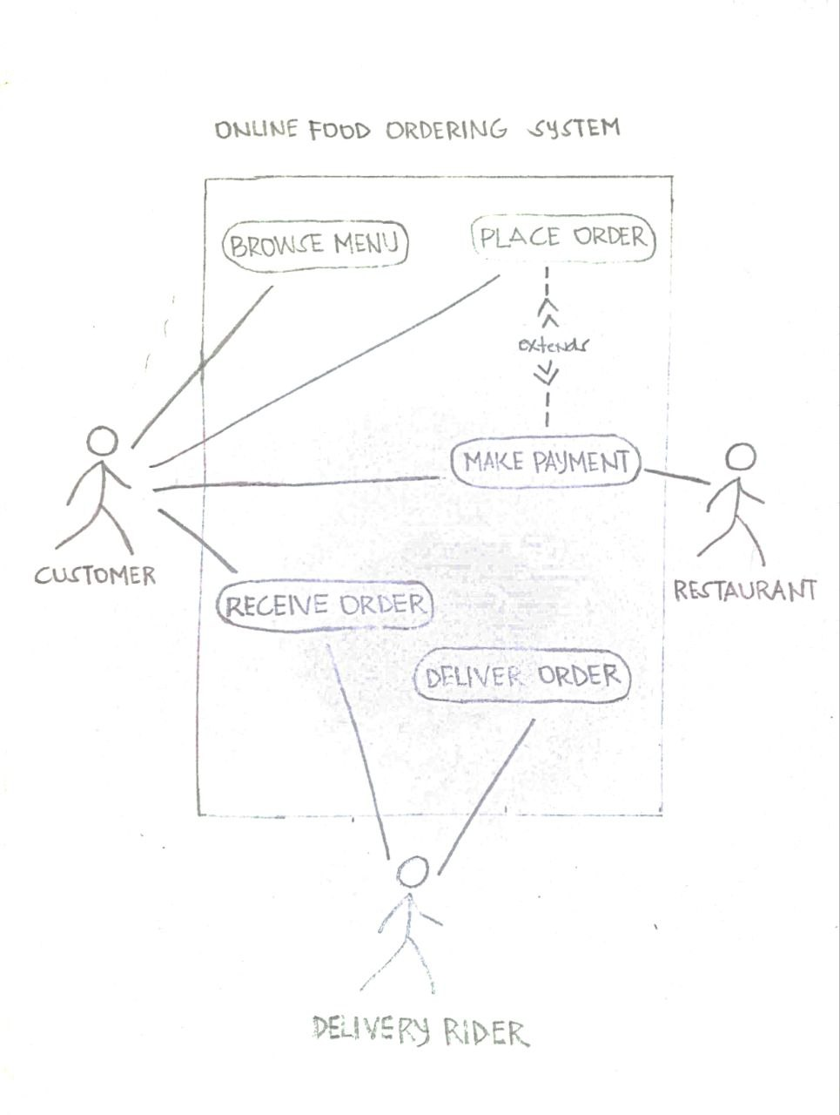
SHORT EXPLANATION
This Use Case Diagram represents an Online Food Ordering System. The diagram shows interactions among three actors: the Customer, the Restaurant, and the Delivery Rider. Each actor performs specific use cases such as browsing the menu, placing orders, preparing food, and delivering orders. I chose the Use Case Diagram because it clearly shows the system’s overall functionality and how different users interact with it.
Members:
Figuracion, John Glenn F.
Baito, Hannah Stephanie B.
Babira, Angellete M.
Cantor, Kairos L.
De Guzman, Christian
Montañano, Sean Jeanric B.

